Create database assignment;

create table Employee

(

EM_ID int PRIMARY KEY AUTO_INCREMENT,

FIRST_NAME varchar(255),

LAST_NAME varchar(255),

SALARY float,

JOINING_DATE date,

DEPARTMENT varchar(200)

);

insert into employee values('null','JOHN','ABRHAM','1000000','2013-01-01','BANKING');

insert into employee values('null','MICHAEL','CLERK','800000','2013-01-01','INSURANCE'),('null','ROY','THOMAS','700000','2013-02-01','BANKING'),

('null','TOM','JOSE','600000','2013-02-01','INSURANCE'),

('null','JERRY','PINTO','650000','2013-01-01','INSURANCE'),

('null','PHILIP','MATHEW','750000','2013-01-01','SERVICES'),

('null','TESTNAME1','123','650000','2013-01-01','SERVICES'),

('null','TESTNAME2','LNAME%','600000','2013-02-01','INSURANCE');

create table Incentives

(

incentive_id int PRIMARY KEY AUTO_INCREMENT,

EMPLOYEE_REF_ID int REFERENCES employee(EM_ID),

INCENTIVE_DATE date,

INCENTIVE_AMT bigint

);

a) Get First_Name from employee table using alias name “Employee Name”.

select FIRST_NAME as EMPLOYEE_NAME from employee;

b) Get FIRST_NAME, Joining year, Joining Month and Joining Date from employee table.

select FIRST_NAME,year(JOINING_DATE),month(JOINING_DATE),day(JOINING_DATE) FROM employee;

c) Get all employee details from the employee table order by First Name Ascending And Salary descending?

SELECT FIRST_NAME,SALARY FROM employee ORDER BY FIRST_NAME ASC,SALARY DESC;

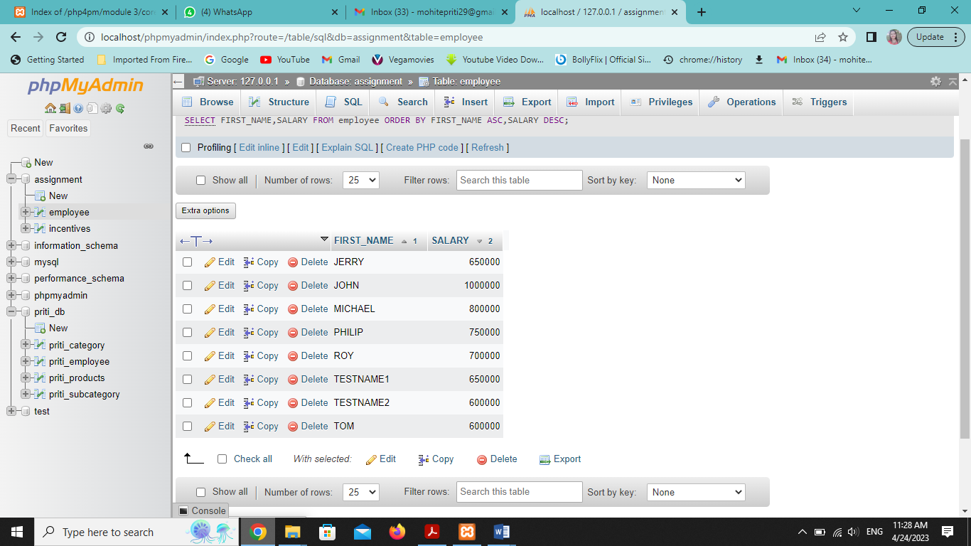

d) Get employee details from employee table whose first name contains „o‟.

SELECT * FROM employee WHERE FIRST_NAME LIKE '%O%';

e) Get employee details from employee table whose joining month is “January”.

SELECT * FROM employee WHERE month(JOINING_DATE)='1';

f) Get department, total salary with respect to a department from employee table

Order By total salary descending.

select sum(SALARY) as total_salary,DEPARTMENT FROM employee GROUP BY DEPARTMENT ORDER BY sum(SALARY) DESC;

g) Get department wise maximum salary from employee table order by salary ascending?

SELECT max(SALARY),DEPARTMENT FROM employee GROUP BY DEPARTMENT ORDER BY SALARY ASC;

h) Select first_name, incentive amount from employee and incentives table for those Employees who have incentives and incentive amount greater than 3000

SELECT INCENTIVE_AMT,FIRST_NAME FROM incentives join employee on incentives.EMPLOYEE_REF_ID=employee.EM_ID WHERE INCENTIVE_AMT>3000;

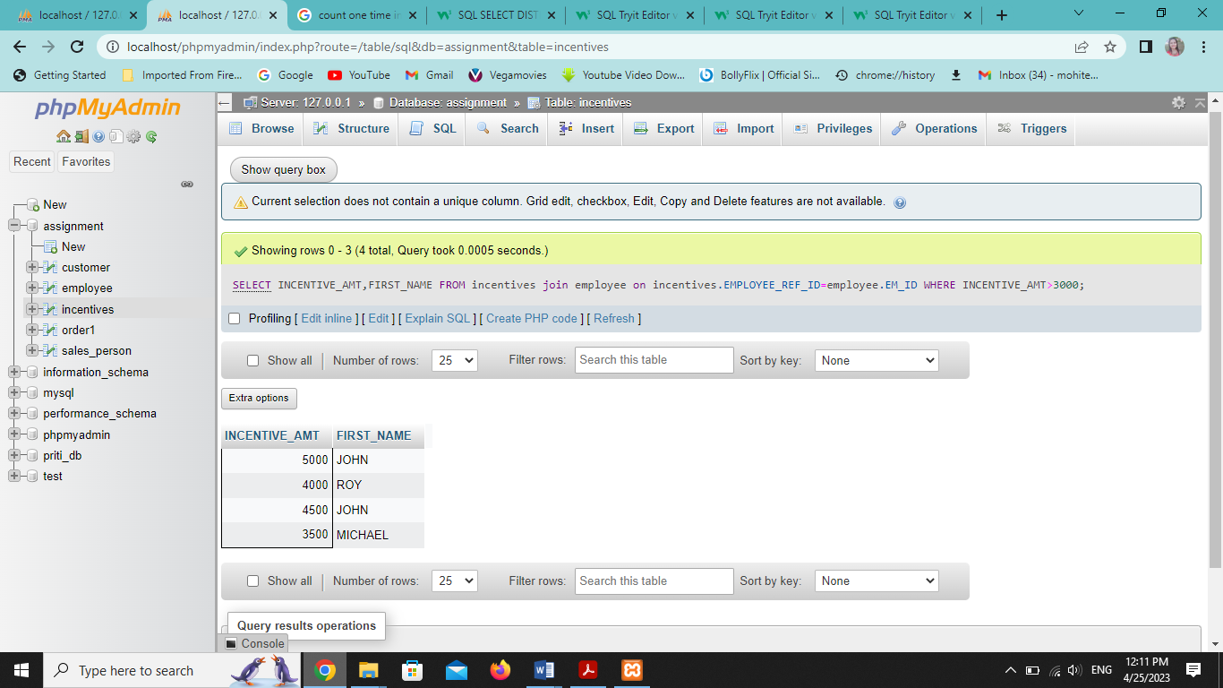

i) Select 2nd Highest salary from employee table.

SELECT max(SALARY) from employee WHERE SALARY < ( SELECT max(SALARY) FROM employee);

j) Select first_name, incentive amount from employee and incentives table for all Employees who got incentives using left join.

SELECT INCENTIVE_AMT,FIRST_NAME FROM incentives LEFT JOIN employee ON incentives.EMPLOYEE_REF_ID=employee.EM_ID;

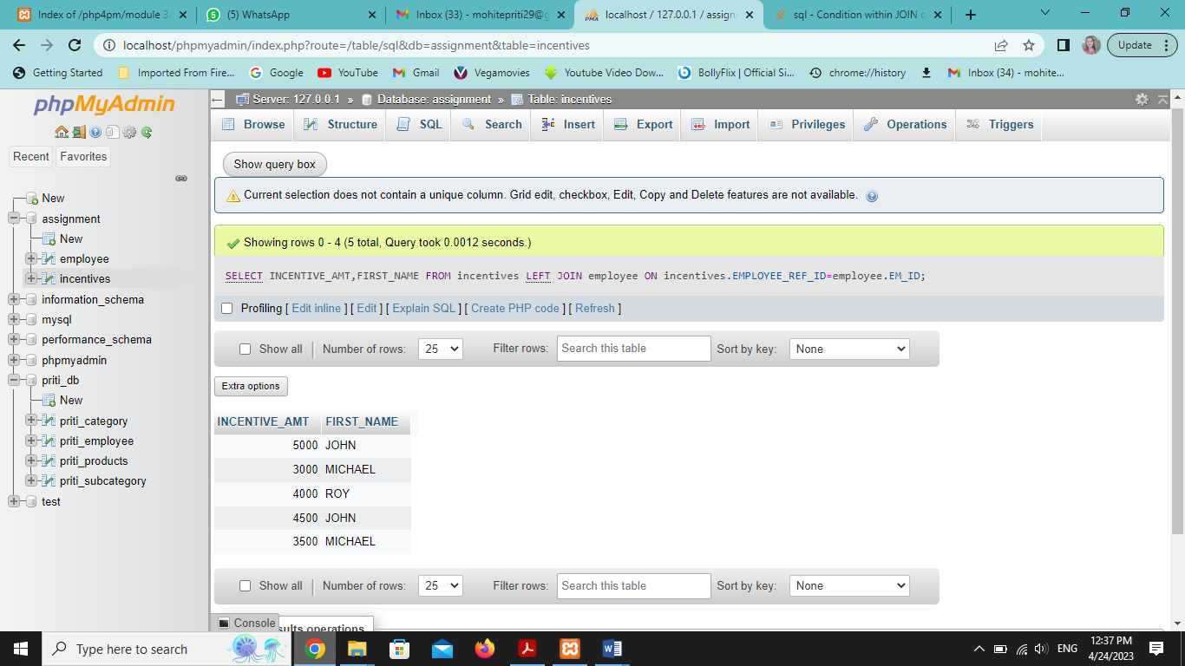

k) Create View OF Employee table in which store first name, last name and salary only.

SELECT FIRST_NAME,LAST_NAME,SALARY FROM employee;

l) Create Procedure to find out department wise highest salary.

SELECT max(SALARY),DEPARTMENT FROM employee GROUP BY DEPARTMENT;

m) Create after Insert trigger on Employee table which insert records in view table.

????????

CREATE TABLE SALES_PERSON;

(INSERT INTO SALES_PERSON VALUES (‘’,’’,’’,’’),

(‘’,’’,’’,’’),

(‘’,’’,’’,’’),

(‘’,’’,’’,’’),

(‘’,’’,’’,’’)

);

CREATE TABLE CUSTOMER

(

CNM INT PRIMARY KEY AUTO_INCREMENT,

CNAME VARCHAR(255),

CITY VARCHAR(255),

RATING BIGINT,

SNO INT REFERENCES sales_person(SNO)

);

INSERT INTO customer VALUES('201','HOFFMAN','LONDON','100','1001'),

('202','GIOVANNE','ROME','200','1003'),

('203','LIU','SAN ROSE','300','1002'),

('204','GRASS','BARCELONA','100','1002'),

('206','CLEMENS','LONDON','300','1007'),

('207','PEREIRA','ROME','100','1004');

CREATE TABLE order1

(

ONM INT PRIMARY KEY AUTO_INCREMENT,

AMT FLOAT,

ODE DATE,

CNM INT REFERENCES customer(CNM),

SNO INT REFERENCES sales_person(SNO)

);

INSERT into order1 VALUES('3001','18.69','1994-10-03','201','1007'),

('3002','1900.1','1994-10-03','207','1004'),

('3003','767.19','1994-01-03','201','1001'),

('3005','3005','1994-01-03','203','1002'),

('3006','3006','1994-10-04','201','1007'),

('3007','3007','1994-10-05','204','1002'),

('3008','3008','1994-10-05','206','1001'),

('3009','3009','1994-10-04','202','1003'),

('3010','3010','1994-10-06','204','1002'),

('3011','3011','1994-10-06','206','1001');

a) All orders for more than $1000.

SELECT * FROM order1 WHERE AMT > 1000;

b) Names and cities of all salespeople in London with commission above 0.10.

SELECT SNAME,CITY,COMM FROM sales_person WHERE COMM > 0.10 AND CITY='LONDON';

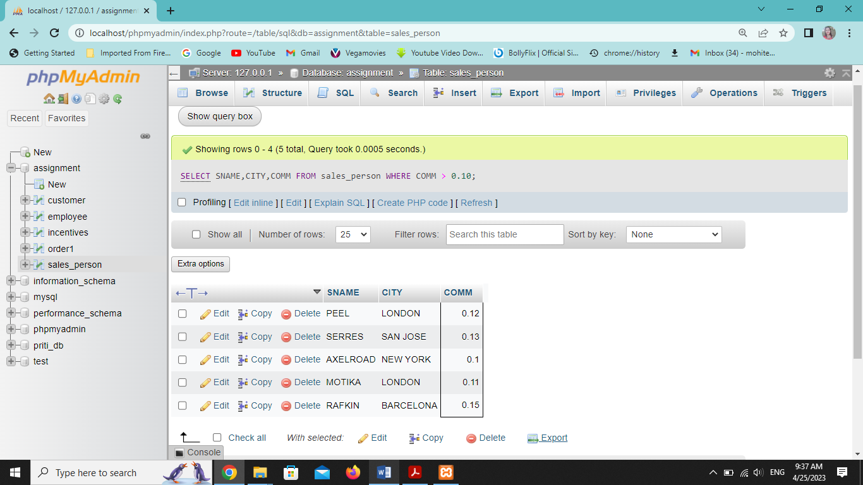

c) All salespeople either in Barcelona or in London.

SELECT * FROM sales_person WHERE CITY in('BARCELONA','LONDON');

d) All salespeople with commission between 0.10 and 0.12. (Boundary values should be excluded).

SELECT * FROM sales_person WHERE COMM BETWEEN 0.1000 and 0.12;

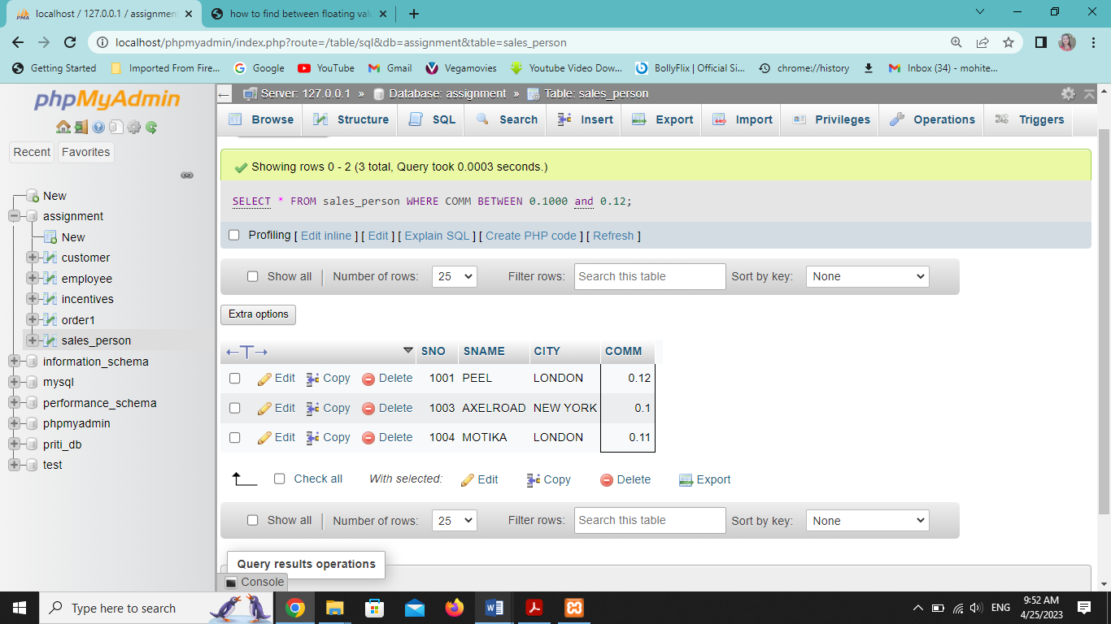

e) All customers with NULL values in city column.

SELECT * FROM customer WHERE CITY=null;

f) All orders taken on Oct 3Rd and Oct 4th 1994.

SELECT * from order1 WHERE ODE in('1994-10-03','1994-10-04');

g) All customers serviced by peel or Motika.

SELECT customer.*,SNAME from customer join sales_person on customer.SNO=sales_person.SNO WHERE SNAME in('PEEL','MOTIKA');

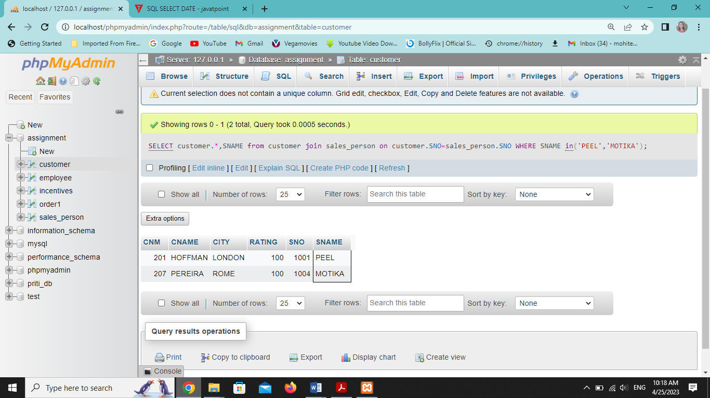

h) All customers whose names begin with a letter from A to B ???

SELECT * FROM customer WHERE CNAME LIKE '[AB]%';

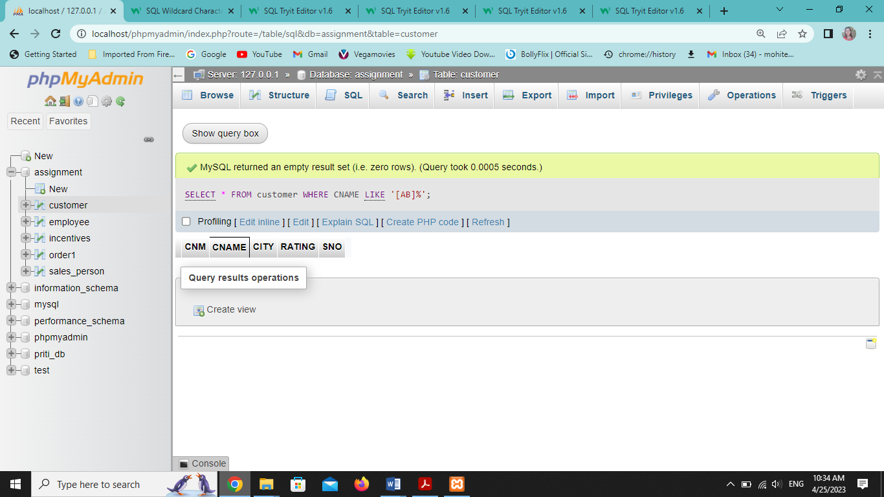

1. All customers excluding those with rating <= 100 unless they are located in Rome.

SELECT * FROM customer WHERE RATING>100 OR CITY='ROME';

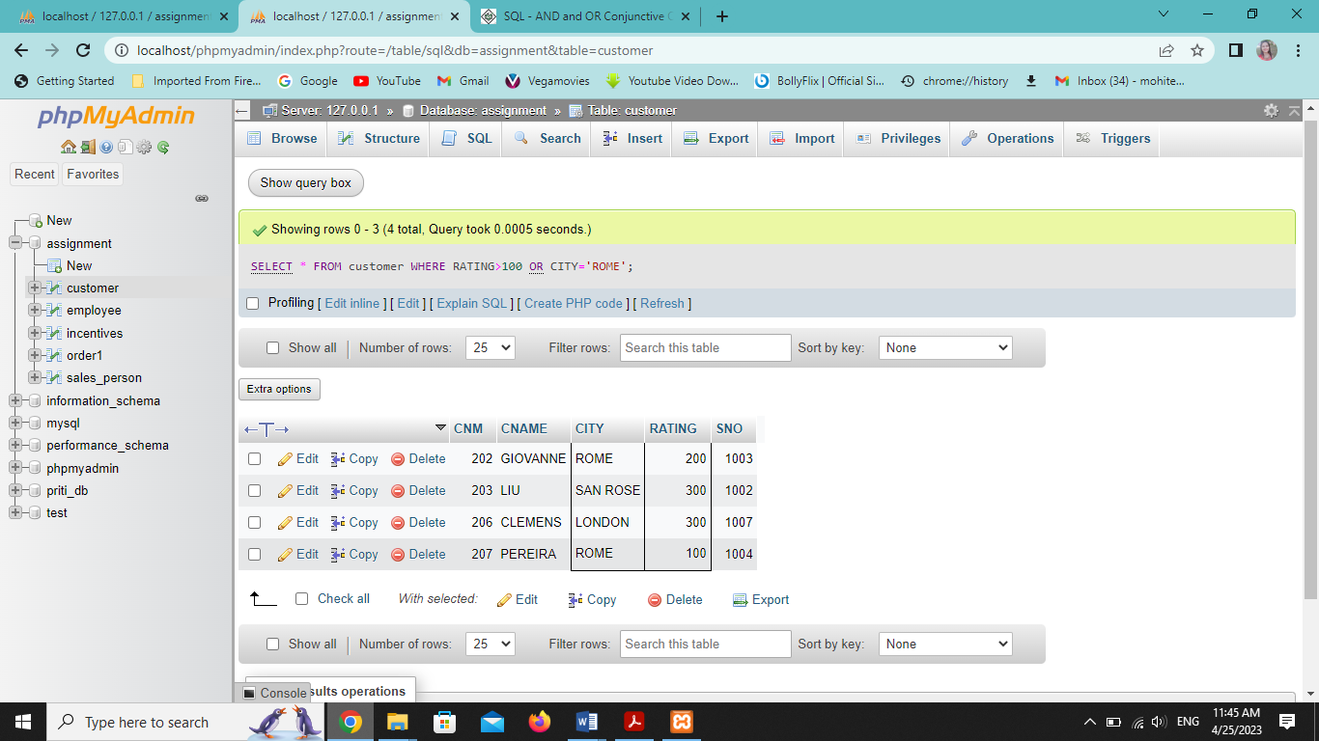

j) All orders except those with 0 or NULL value in amt field.

SELECT * FROM order1 EXCEPT SELECT * FROM order1 WHERE AMT='NULL';

OR

SELECT * FROM order1 WHERE AMT!='NULL';

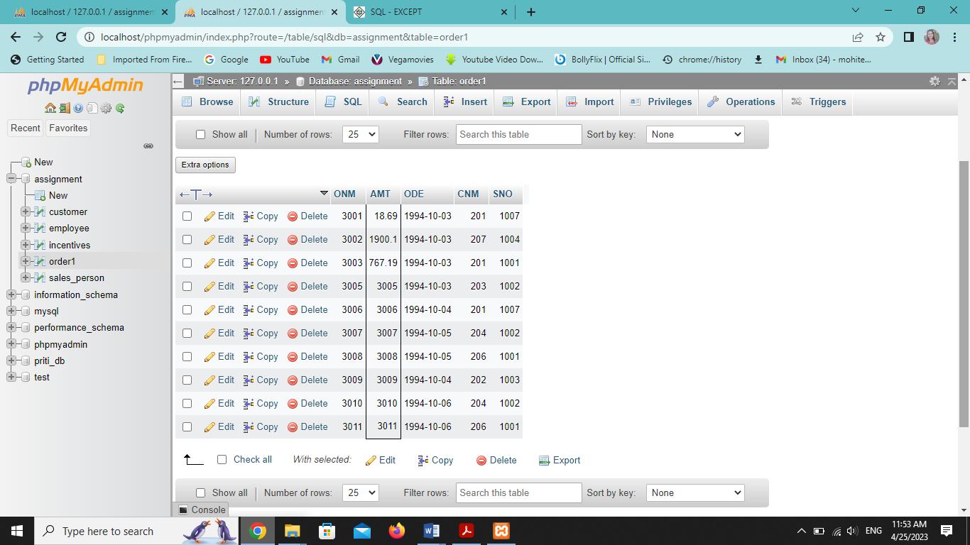

k) Count the number of salespeople currently listing orders in the order table.

SELECT COUNT(DISTINCT SNO) FROM order1;

